How To Build a Release of Stars!Nova

1/ set Global.debug to False:
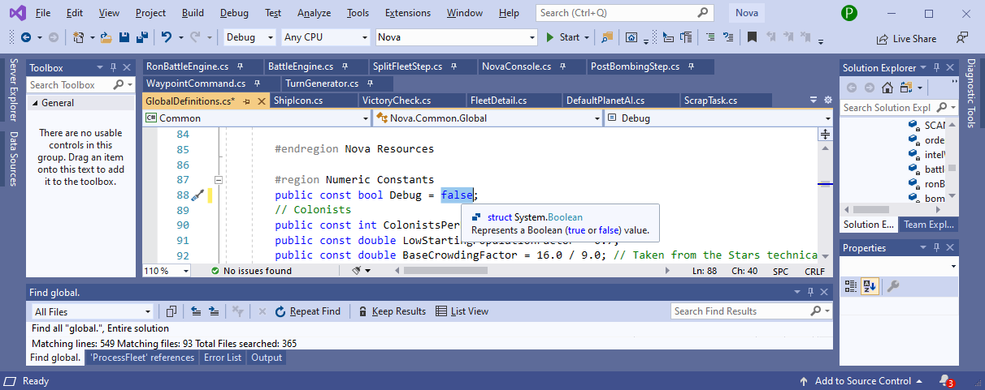
2/ if components.xml has changed update components.zip

3/ if DefaultRaces folder has changes update DefaultRaces.zip

4/ if files in the Graphics directory tree have changed update Graphics.zip

5/ Publish the project

6/ Create a self-extracting 7zip file that contains all of the published material:
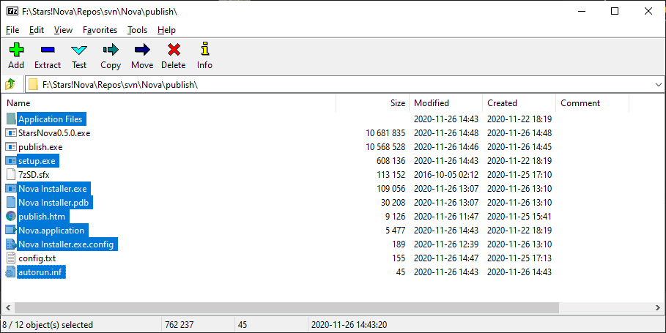
files like autorun and publish.htm probably aren't needed but it works if they are included.
Click on Add

select SFX:

and then “OK”

- wrap the Microsoft installer in something dumb enough to work:

Dr Frankenstein – StarsNova0.5.0.exe is Alive!!!

